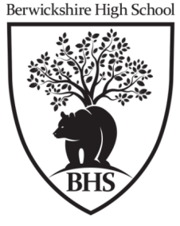
Physical Environments
Weather
Depressions and Anticyclones
Edinburgh and Nice will be experiencing very different weather conditions.
Give reasons for these differences. (4 Marks, 2022)

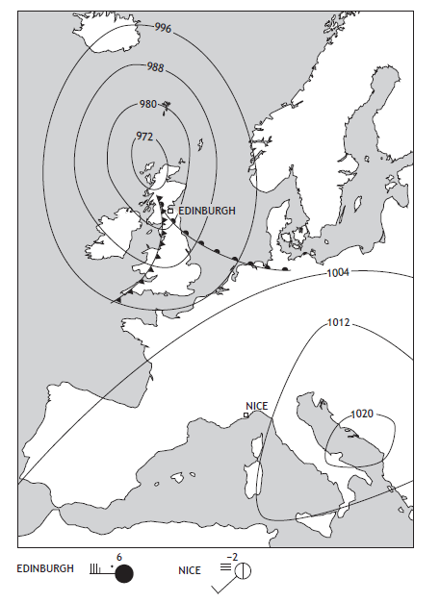
Answers may include:
• Edinburgh has strong winds but in Nice it is calmer, because in Edinburgh there are tightly packed isobars whereas in Nice there aren’t (1 mark)
• the wind is from the W in Edinburgh because air moves anticlockwise around the low pressure, whereas it is from the SW in Nice because winds blow clockwise around an area of high pressure (1 mark)
• it is rainy in Edinburgh because there is a warm front approaching but there is no rain in Nice because there are no fronts (1 mark)
• in Nice there is high pressure which often brings very cold conditions in winter whereas in Edinburgh the temperature is higher because of cloud cover (1 mark)
• in Nice there is fog which blocks out the sunshine keeping temperatures low, unlike in Edinburgh (1 mark)
• in Nice there is little cloud cover which is common in high pressure areas whereas at Edinburgh there is 8 oktas of cloud because it is close to a front (1 mark)
• conditions are much more unsettled in Edinburgh because it is in a depression whereas Nice is in an anticyclone. (1 mark)
Or any other valid point.
‘Sunny intervals will give way to heavy showers. Winds, at first strong, will become lighter and more westerly. Temperatures will drop.’ Using the synoptic chart, give reasons for the changes which the weather forecast predicts for Penzance during Sunday 26 February. (4 marks, diagram, 2019)

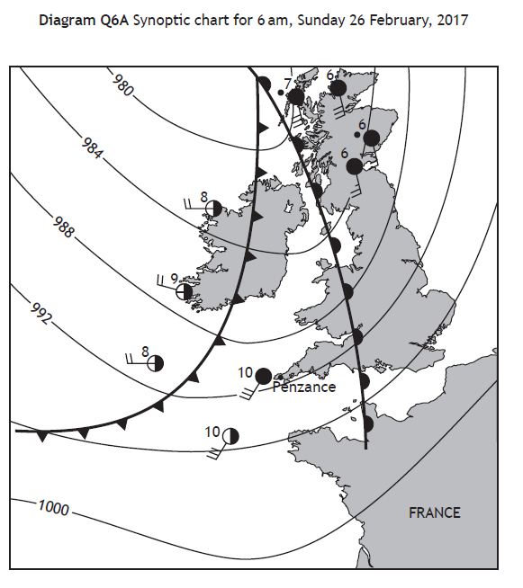
• as the cold front approaches, the temperature falls as cooler air replaces warmer air on the surface (1 mark)
• cold fronts bring periods of heavy precipitation explaining the heavy showers of rain in the forecast (1 mark)
• as the cold front moves past Penzance it will bring clearer conditions (1 mark) and there are less clouds allowing periods of sunshine (1 mark)
• the isobars are further apart behind the cold front so winds are lighter (1 mark)
• the direction of the isobars changes after the cold front, explaining why the wind will change direction from SW to W. (1 mark)

Or any other valid point.

Explain the changes that will take place in the weather in Stirling over the next 24 hours. ( 5 marks,2018)

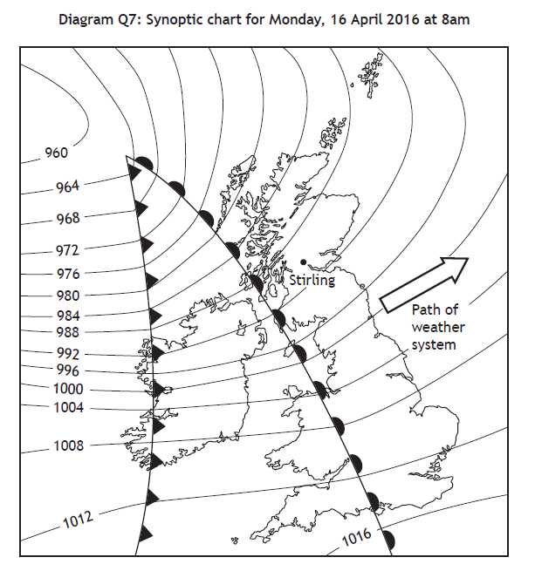

Due to the approach of the warm front, Stirling’s air pressure will fall (1) cloud cover will increase (1) and steady rain will fall (1). Winds will be stronger as the isobars are closer together (1). Because Stirling will be in the warm sector of a depression, temperatures will rise (1) and it will be mild with some cloud cover and occasional showers (1). Due to the cold front arriving, cloud cover will increase (1) with cumulonimbus clouds bringing heavy rainfall to Stirling (1). Temperatures will drop as the cold front passes over (1). As the front begins to move away, the sky will become clear (1) rain will stop (1) air pressure will begin to rise (1).
Or any other valid point.

Give reasons for the weather conditions at Bathgate on 28th December 2014 ( 5 marks, diagram, 2017)

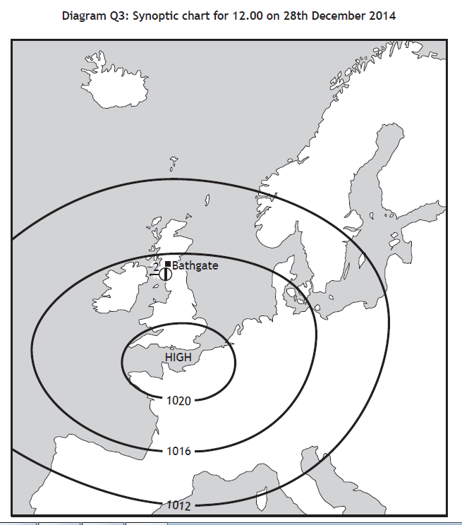

It is -2C because it is a high pressure/winter anticyclone (1) and there is often a lack of cloud allowing heat to escape, bringing low temperatures (1). The temperature is very cold because it is December in the UK i.e. winter time (1). Winds will be gentle as isobars are widely spaced (1). Wind direction is westerly as winds blow clockwise around anticyclones in UK (1). There is little cloud (1 okta) as cold air sinks in an anticyclone (1). The weather is dry as there are no fronts to bring rain/snow (1).

Or any other valid point.

Anticyclones bring different weather conditions throughout the year.
Describe the benefits and problems of an anticyclone in summer. ( 4 marks, 2017)

Advantages
Warm, dry and sunny weather improves peoples’ mood (1). People can participate in more outdoor activities such as BBQs (1). Outdoor sports can take place eg tennis matches without being rained off (1). School sports days can safely go ahead due to dry conditions (1). Rising sales of summer goods such as sunscreen and ice lollies increase shops profits (1).
Disadvantages
Hose-pipe bans enforced due to lack of water (1). Drought conditions reduce the yield of farmers’ crops (1). People suffer from sunburn and dehydration (1). More people admitted to hospital with heatstroke (1) putting a strain on resources (1). Forest fires break out (1). Thunderstorms are also a disadvantage of anticyclones (1).

Or any other valid point.

Which weather chart x or y, is more likely to show the weather conditions being experienced in Britain on December 24th 2014? Give reasons for your choice. ( 5 marks, diagram, 2016)

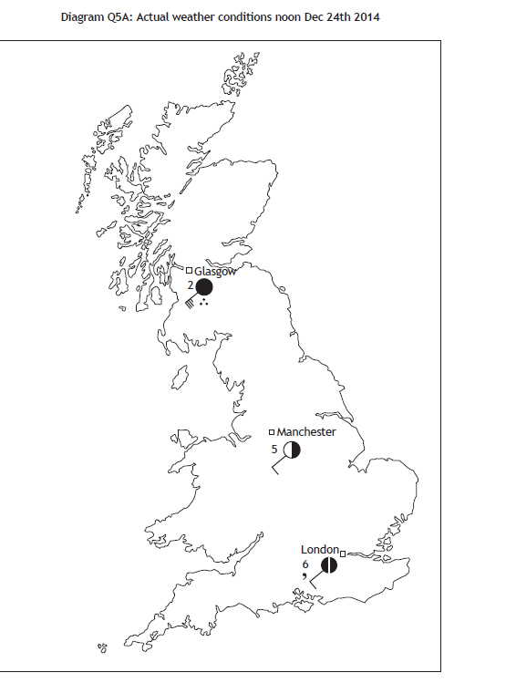

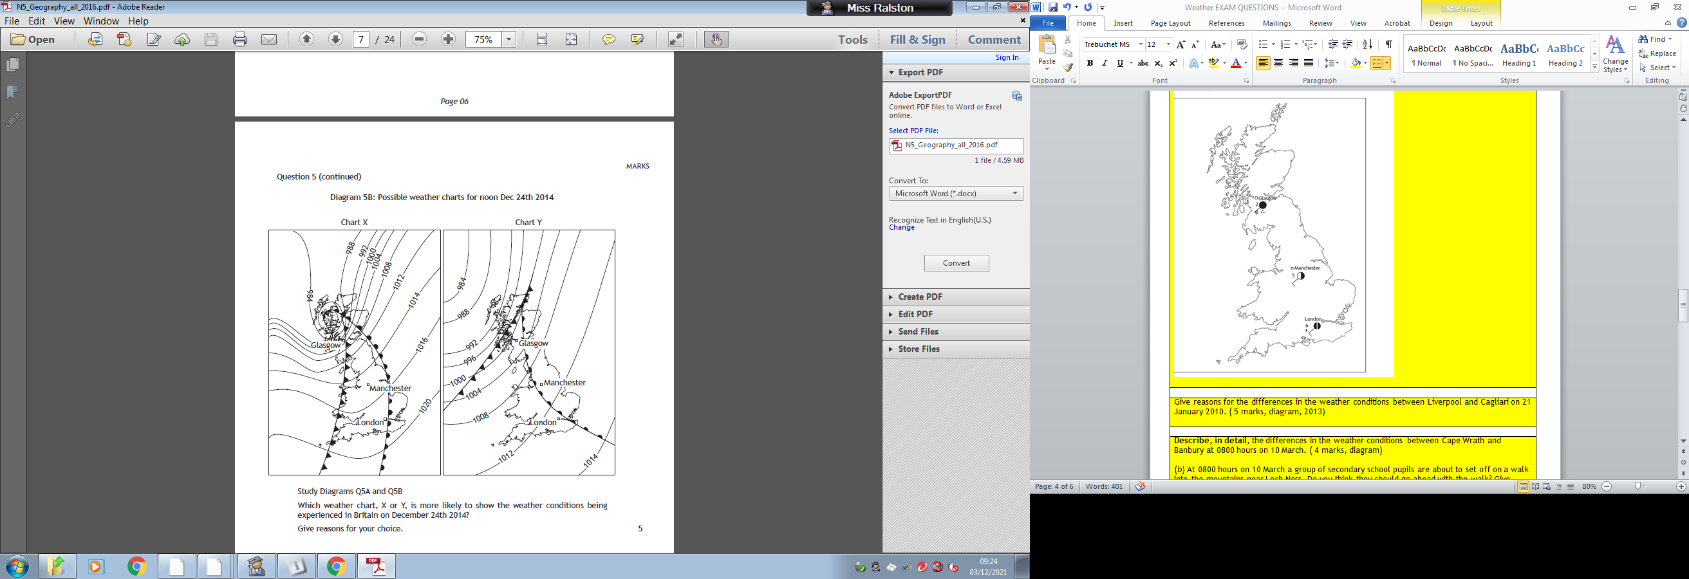

If Chart X chosen:
A warm front has just passed over London, which will bring drizzle as shown in Diagram Q5A(1)
Manchester is in the warm sector, so it is warmer and drier than Glasgow, as shown on Diagram Q5A(1)
As Manchester is between fronts, the cloud cover there is less than Glasgow or London (1)
Glasgow is experiencing a cold front, so there is heavy rain as shown on Diagram Q4 (1)
The isobars are farther apart in London than in Glasgow and this explains the lighter winds in London (1).
A warm front has just passed over London, explaining the 7 oktas of cloud cover. (1).

If Chart Y chosen:
London is experiencing drizzle as shown on Diagram Q5A and this is possible in the warm sector (1)
The isobars are close together in the north, explaining the higher winds shown on Diagram Q5A(1)
As the warm front is yet to reach Manchester, Manchester is cooler than London (1)
The warm front has just passed over London meaning that it would be cloudy, accounting for the 7 oktas of cloud cover (1)

Any other valid point.

Give reasons for the differences in the weather conditions between Liverpool and Cagliari on 21 January 2010. ( 5 marks, diagram, 2013)
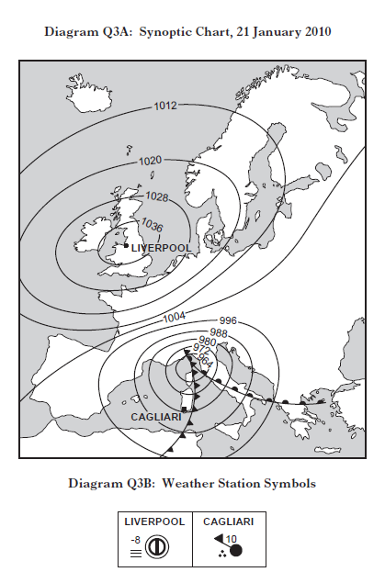

1 mark for identifying Liverpool is in an anticyclone and Cagliari is in a depression.

No marks for description.

Answers must give reasons for differences between Liverpool and Cagliari.

Answers may include:
Cagliari has gale force winds but in Liverpool it is calm, because in Cagliari there are tightly packed isobars whereas in Liverpool there aren’t (1); the wind is from the NW in Cagliari because air moves anticlockwise around the low pressure, whereas it is from the NE in Liverpool it is calm because it is in the centre of high pressure (1). There is a cold front causing heavy rain in Cagliari but there is no rain in Liverpool because there are no fronts (1); the temperature is much warmer in Cagliari because it is just leaving the warm sector whereas in Liverpool there is high pressure which often brings very cold conditions in winter (1); also in Liverpool there is fog which blocks out the sunshine, keeping temperatures low, unlike in Cagliari (1); temperatures may also be warmer in Cagliari because it is over 1000 kilometres further south (1). In Liverpool there is little cloud cover which is common in high pressure areas whereas at Cagliari there is 8 oktas of cloud because it is on the cold front (1). Conditions are much more unsettled in Cagliari because it is in a depression whereas Liverpool is in an anticyclone (1).

Or any other relevant point.
Describe, in detail, the differences in the weather conditions between Cape Wrath and Banbury at 0800 hours on 10 March. ( 4 marks, diagram)

(b) At 0800 hours on 10 March a group of secondary school pupils are about to set off on a walk into the mountains near Loch Ness. Do you think they should go ahead with the walk? Give reasons for your answer. ( 4 marks, 2012)

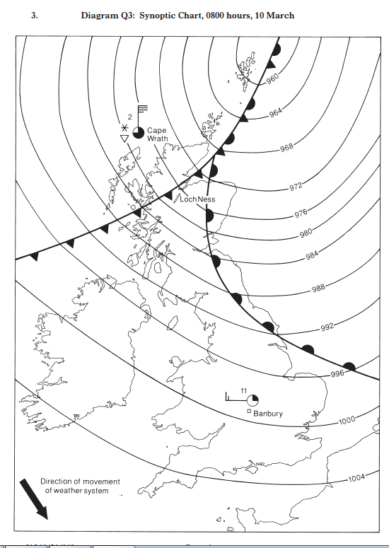

Part A
Cape Wrath has a north wind whereas Banbury has a west wind (1). It is 35 knots at Cape Wrath but calmer in Banbury at 15 knots (1). It is dry in Banbury but there are snow showers at Cape Wrath (1). There is 6 oktas cloud cover at Cape Wrath but only 2 oktas over Banbury (1). The temperature at Cape Wrath is much colder at 2C, while at Banbury it is 11C (1).

Part B
Yes: | After the cold front has passed there will be fewer clouds and less rain (2). If they have the right gear they will be protected from the strong winds and cold temperatures (1). There could be good visibility between the showers as there will be clear air coming in from the north and this will help them find their way on the hills (2).
No: | They should not go walking in the hills as there is a cold front about to arrive in the area (1) which will bring heavy rain showers (1). It will also cause the temperatures to drop close to freezing point and there could be snow (2). If they are not properly equipped they could suffer from the cold and get hypothermia (1) especially as the isobars are close together resulting in a high wind chill (1). If there is heavy snow or low cloud they could lose their way easily and need to be rescued (1) these conditions are life threatening and they should wait for a better day (1).

With reference to the weather chart, explain why London’s New Year celebrations went ahead whilst the celebrations in Glasgow were cancelled. ( 5 marks, diagram, 2011)

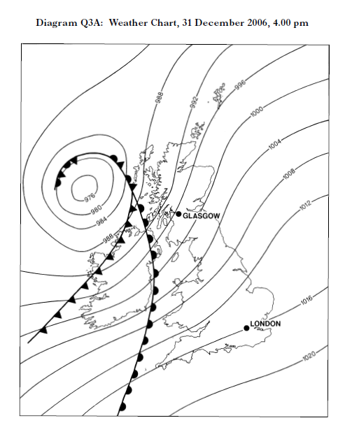

There is a warm front close to Glasgow causing cloud cover and wind (1). The isobars are close together so Glasgow will be experiencing strong winds (1) which will continue to increase as the front gets nearer (1). In the next few hours the front will be over Glasgow bringing steady rainfall (1). There are no fronts close to London so it will be drier and clearer (1). The isobars are further apart so it will be less windy (1). The warm front is further away so it will take longer to reach London, allowing the celebrations to go ahead (1).

Describe similarities and differences in weather conditions caused by anticyclones in summer and winter. ( 4 marks, 2010)

Explain the changes which will take place in the weather in Glasgow over the next 24 hours. ( 6 marks, diagram, 2009)

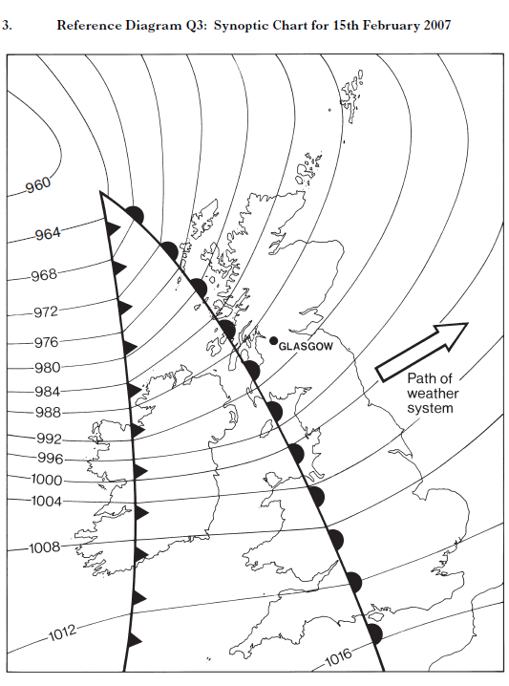

Similarities
In both summer and winter, wind speeds are light or calm towards the centre of the anticyclone (1); in both summer and winter winds circulate in a clockwise direction (1); there are few clouds in the sky at both times of year (1); anticyclones bring a spell of settled weather in both summer and winter (1); there may be mist in the morning at
both times of year (1).

Differences
Anticyclones bring hot weather in summer but very cold weather in winter (1); heat waves can occur in summer if an anticyclone remains over the UK for a period of time (1); however during winter severe frosts are common at night and during the day (1); cooling of the ground leads to morning mist in summer, but in winter fog lasting part/all of the day is common (1); warm moist air rising from the ground can form thunderstorms in summer (1).

Weather factors affecting the UK
Explain the factors which affect average temperatures in the UK.( 4 marks, 2018)

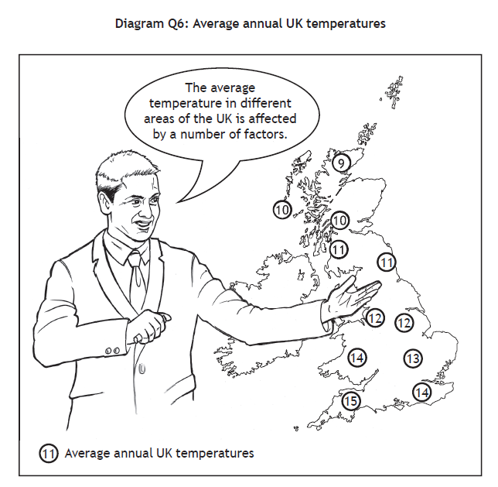
Latitude: places in southern England are warmer because they are nearer the Equator (1); temperatures generally decrease the further north you go because the sun’s rays are less concentrated further away from the equator (1). It’s colder in northern Scotland because there is more atmosphere for the sun’s rays to pass through (1)

Altitude/Relief: upland areas are colder as temperatures decrease 1C for every 100 metres gained in height (1) and wind speeds increase as altitude increases which can affect temperature (1).

Aspect: in the northern hemisphere south facing slopes can be warmer because they face the sun (1). North facing slopes are shaded from the sun and are therefore cooler (1).

Continentality/Distance from the sea: places closer to the sea have warmer/milder winters and cooler summers because oceans heat up slowly in summer and cool slowly in winter (1) oceans act as ‘thermal reservoirs’ (1) whereas places further inland have a greater annual range in temperature due to distance from the effects of the oceans (1). The North Atlantic Drift keeps the temperatures warmer on the west coast than on the east coast of the UK (1)

Or any other valid point.
Explain the factors which cause differences in average UK temperatures. ( diagram, 4 marks, 2015)

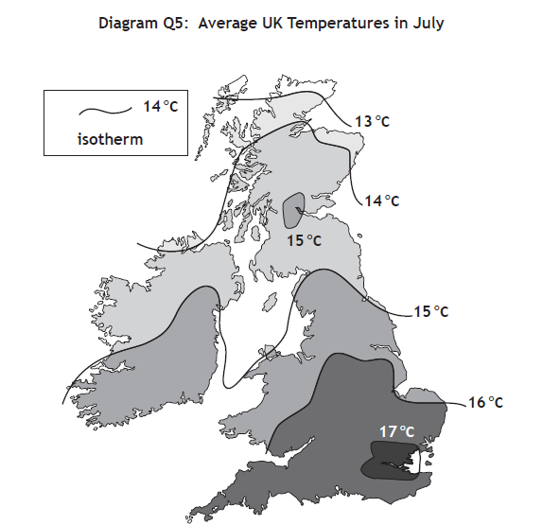
South-East England is usually warmer because it is closer to the Equator (1). This is due to intense heating from the sun (1) because sun rays are more concentrated (1). Places in Northern Scotland eg Wick, are colder because they are closer to the North Pole(1). This is due to a lack of insolation from
the sun as the rays are less concentrated (1) and reflection of heat by the snow and ice (1). Places located on flat low-lying land are warmer eg Central Scotland, because temperatures increase as altitude decreases and places higher up ie mountainous regions are colder (1) because temperature decreases by 1oC for every one hundred metres in height (1).

Places which are south facing are warmer because they get more sun (1) and places which are north facing are colder because they experience cold northerly winds (1). Western coastal areas are warmer because of a warm ocean current (1) (The North Atlantic Drift) and due to the prevailing

South-Westerly winds that are warmed as they pass across this warm ocean current (1). In summer, places closer to the sea are cooler and in winter they are warmer because the sea heats up slowly in summer and cools slowly in winter (2).

Or any other valid point.

Describe how a prolonged spell with a tropical continental air mass in summer would affect the people of the British Isles. ( 3 marks, 2014)
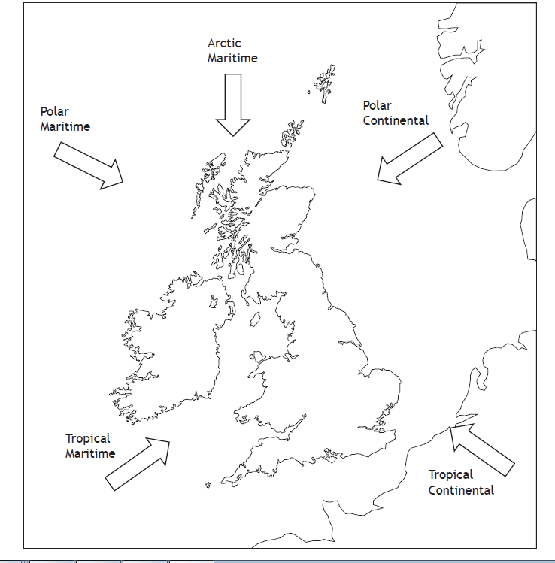

A tropical continental air mass will bring hot dry weather in summer which could result in droughts (1); there might need to be hosepipe bans (1); grass might wither and die causing problems for livestock farmers (1); ice cream sales might rise (1) as people make the most of the sunny weather and head for the beach (1); it could be very hot and difficult to do physical work outside (1); heavy rain from thunderstorms might cause flash floods (1).

Or any other valid point.

Weather Station Circle


Draw a weather station circle to show the weather conditions described:
northerly wind
30 knots
snow showers
sky obscured (4 marks, 2019)

Give reasons for the differences in the weather conditions between Ballycastle and Lerwick. ( 5 marks, diagram, 2014)

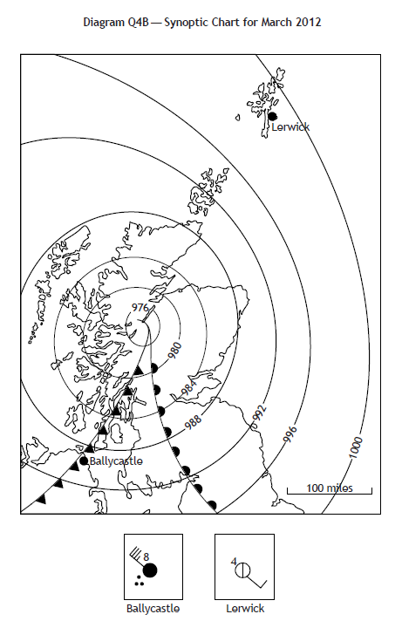

It is much windier at Ballycastle than Lerwick because the isobars are much closer together in Ireland (1); it is raining heavily at Ballycastle because it is next to the cold front whereas Lerwick is not close to any fronts (1); the wind direction is north west at Ballycastle and south east at Lerwick because the wind goes anticlockwise around the low pressure and the isobars show the approximate direction (1); the cloud cover is 8 oktas at Ballycastle because it is so close to the cold front where there is likely to be cumulonimbus cloud whereas Lerwick is not near any fronts so is less likely to have cloud (1); the temperature is warmer at Ballycastle as it is still in the warm sector whereas Lerwick is not (1); the weather is mostly worse in Ballycastle than Lerwick as it is closer to a depression (1). It is warmer in Ballycastle because the clouds trap the heat whereas it is colder in Lerwick because there are no clouds (1)

Or any other valid point.

