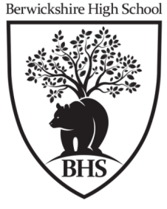
Physical Environments
Weather
Depressions and Anticyclones
Edinburgh and Nice will be experiencing very different weather conditions.
Give reasons for these differences. (4 Marks, 2022)

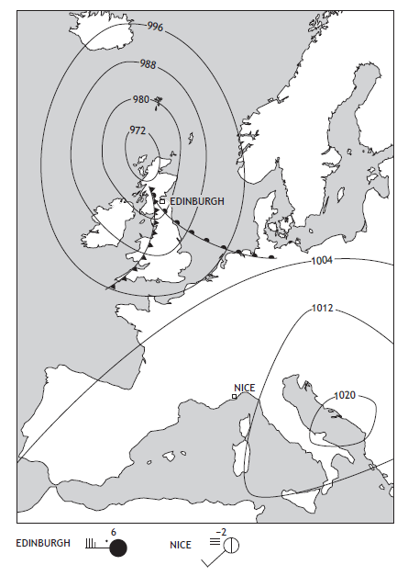
‘Sunny intervals will give way to heavy showers. Winds, at first strong, will become lighter and more westerly. Temperatures will drop.’ Using the synoptic chart, give reasons for the changes which the weather forecast predicts for Penzance during Sunday 26 February. (4 marks, diagram, 2019)

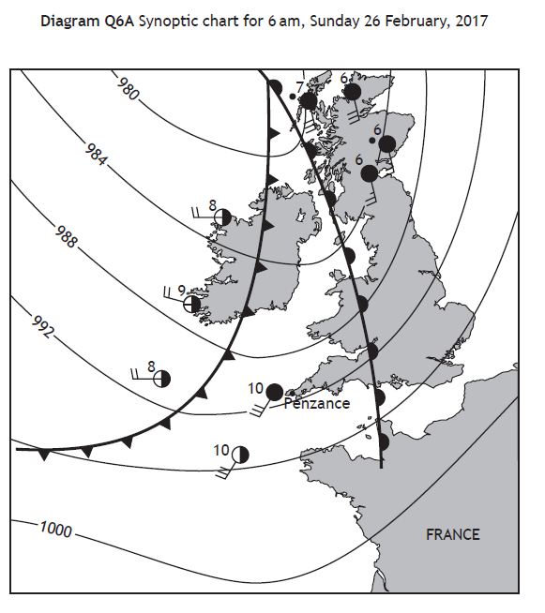
Explain the changes that will take place in the weather in Stirling over the next 24 hours. ( 5 marks,2018)

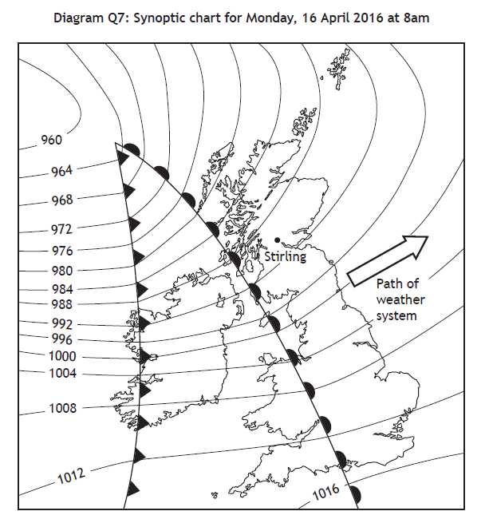

Give reasons for the weather conditions at Bathgate on 28th December 2014 ( 5 marks, diagram, 2017)

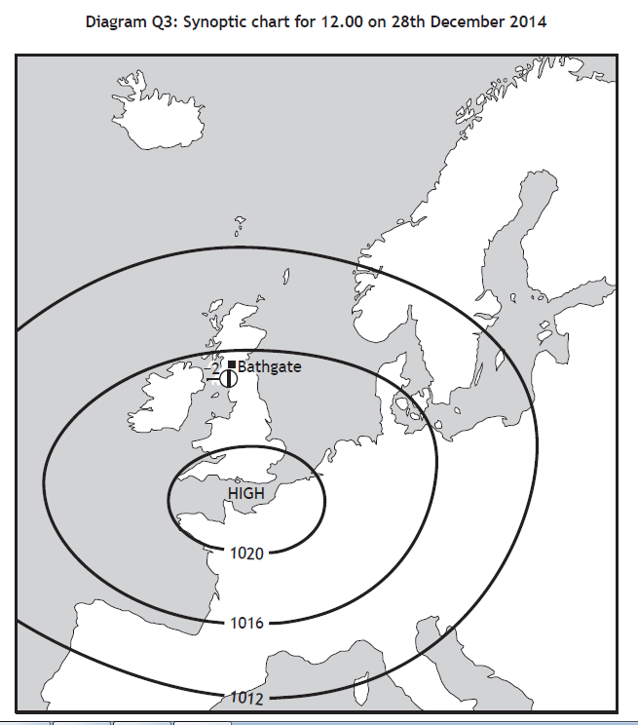

Anticyclones bring different weather conditions throughout the year.
Describe the benefits and problems of an anticyclone in summer. ( 4 marks, 2017)

Which weather chart x or y, is more likely to show the weather conditions being experienced in Britain on December 24th 2014? Give reasons for your choice. ( 5 marks, diagram, 2016)

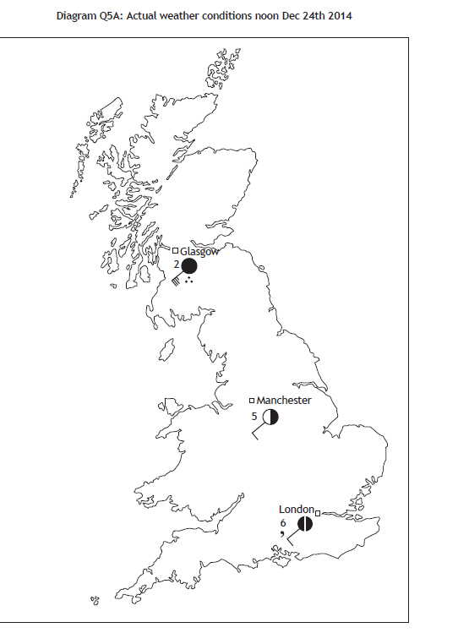

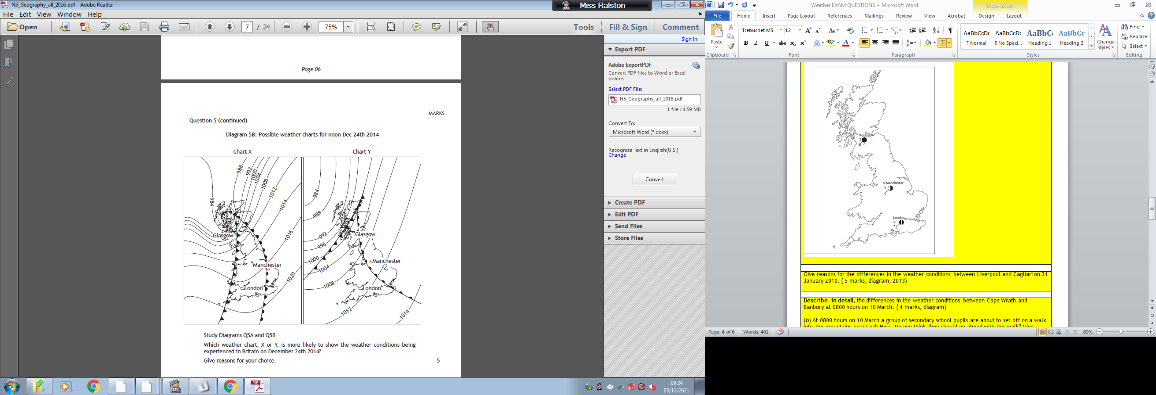

Give reasons for the differences in the weather conditions between Liverpool and Cagliari on 21 January 2010. ( 5 marks, diagram, 2013)
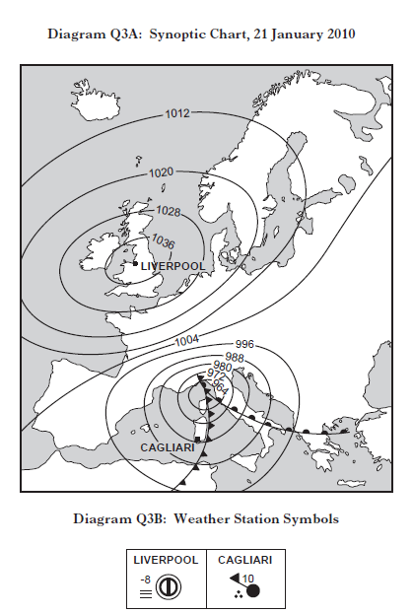

Describe, in detail, the differences in the weather conditions between Cape Wrath and Banbury at 0800 hours on 10 March. ( 4 marks, diagram)

(b) At 0800 hours on 10 March a group of secondary school pupils are about to set off on a walk into the mountains near Loch Ness. Do you think they should go ahead with the walk? Give reasons for your answer. ( 4 marks, 2012)
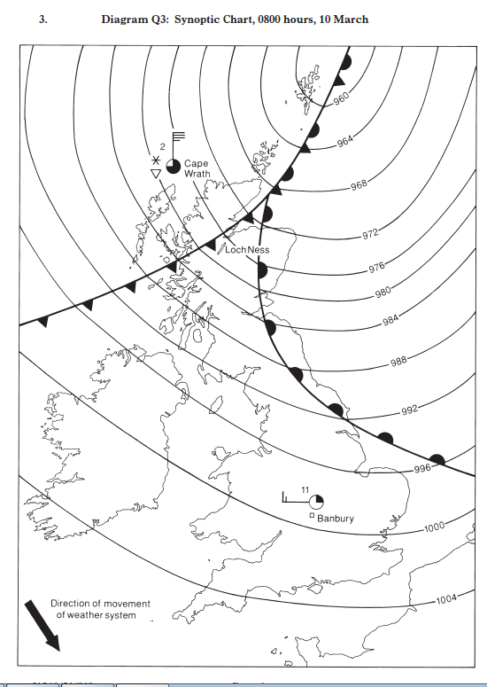

With reference to the weather chart, explain why London’s New Year celebrations went ahead whilst the celebrations in Glasgow were cancelled. ( 5 marks, diagram, 2011)

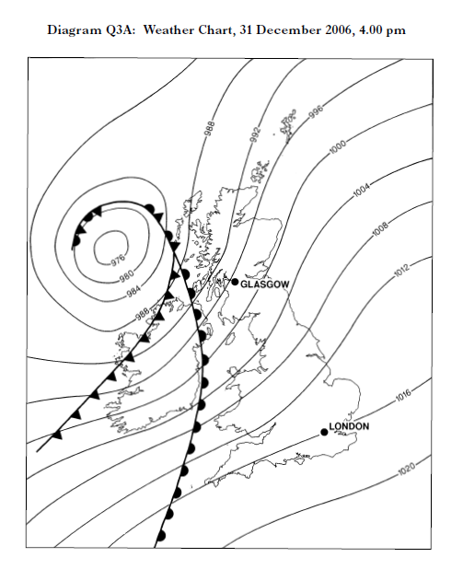

Describe similarities and differences in weather conditions caused by anticyclones in summer and winter. ( 4 marks, 2010)

Explain the changes which will take place in the weather in Glasgow over the next 24 hours. ( 6 marks, diagram, 2009)

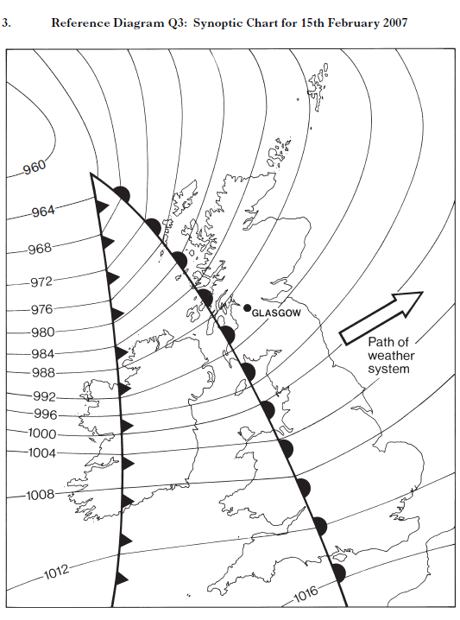

Weather factors affecting the UK
Explain the factors which affect average temperatures in the UK.( 4 marks, 2018)

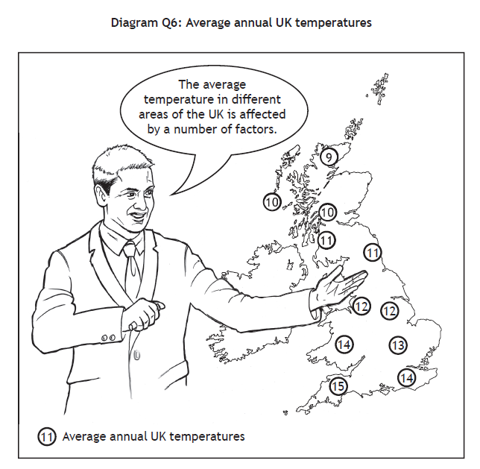
Explain the factors which cause differences in average UK temperatures. ( diagram, 4 marks, 2015)

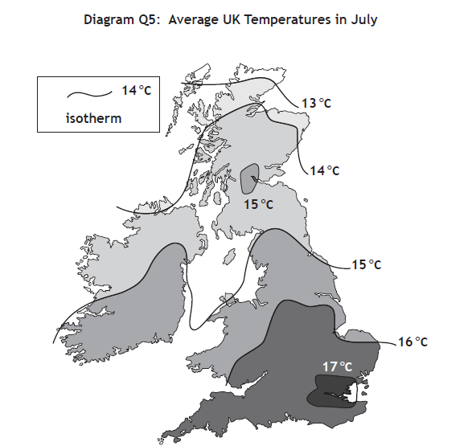
Describe how a prolonged spell with a tropical continental air mass in summer would affect the people of the British Isles. ( 3 marks, 2014)
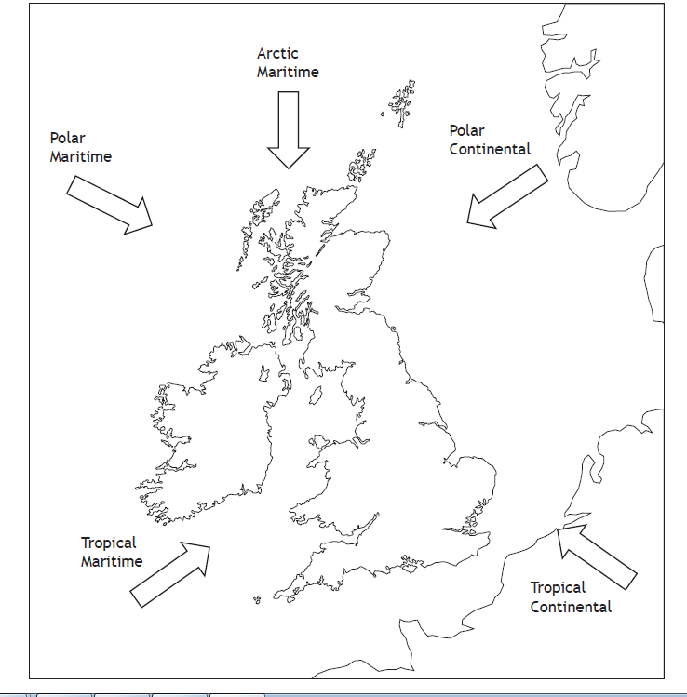

Weather Station Circle
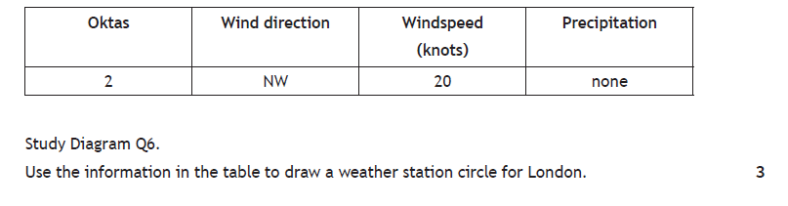
Draw a weather station circle to show the weather conditions described:
northerly wind
30 knots
snow showers
sky obscured (4 marks, 2019)

Give reasons for the differences in the weather conditions between Ballycastle and Lerwick. ( 5 marks, diagram, 2014)



